IndiaKart E-Commerce Analytics

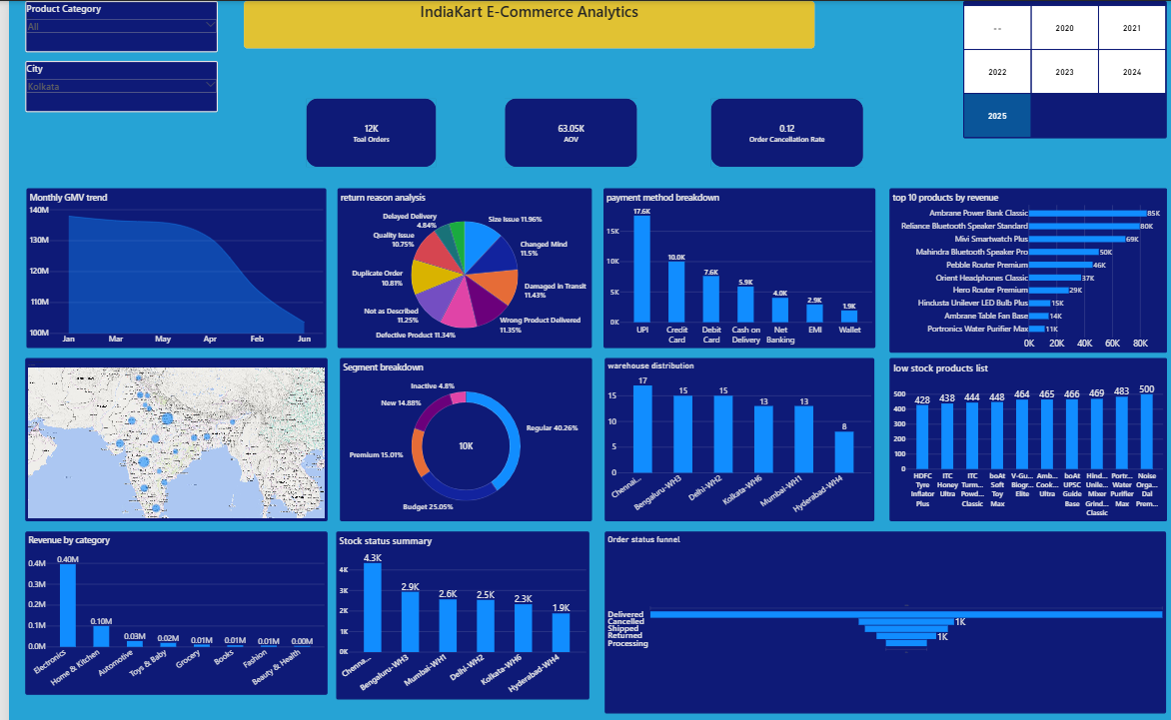

1. Executive Summary
- The IndiaKart E-Commerce Analytics Project analyzed 8 interconnected datasets containing approximately 216,200 records across 24 months of business operations.
- The project followed an end-to-end analytics workflow using Python, SQL Server, SQL, and Power BI for data cleaning, relational data storage, business analysis, EDA, KPI calculations, and dashboard development. Key areas analyzed include revenue, customers, products, categories, orders, payments, returns, geographic performance, and inventory.
- The final interactive dashboard consolidates key business metrics and insights to support performance monitoring and data-driven decision-making.

2. Problem Solved
- IndiaKart’s business data was distributed across multiple datasets, making it difficult to obtain a consolidated view of revenue, customer, product, order, payment, return, and inventory performance.
- The project addressed this by cleaning and preparing the raw data in Python, storing it in a structured SQL Server database, performing SQL-based business analysis and Python EDA, calculating key KPIs, and presenting the results through an interactive Power BI dashboard.
- This end-to-end solution transforms raw e-commerce data into clear, actionable business insights for identifying trends, risks, and growth opportunities.
3.Key Insights
- Electronics is the highest revenue-generating category at ₹164.24 Cr, significantly outperforming all other categories.Sports & Fitness ranks second at ₹49.72 Cr, highlighting a strong revenue concentration in Electronics.
- Premium customers do not record the highest Average Order Value (AOV), averaging approximately ₹62K per order, while the Budget segment leads at around ₹64K, indicating that higher customer segmentation does not necessarily correspond to higher per-order spending.
- Festive-season sales remained strong across the October–November Diwali window, with revenue reaching approximately ₹13.25 Cr in Oct 2023 and ₹13.73 Cr in Nov 2023, compared with ₹13.35 Cr and ₹12.63 Cr respectively in 2024.The results indicate that November 2023 delivered the strongest festive performance, while the decline in November 2024 suggests comparatively weaker post-October festive demand despite a slight year-over-year improvement in October sales.
- Size Issue is the most common reason for product returns, followed by Changed Mind, Damaged in Transit, Wrong Product Delivered, and Defective Product, indicating that both product-fit and fulfilment-related issues are major drivers of returns.Delayed Delivery and Better Price Found are the least reported return reasons, suggesting that product and order-quality issues contribute more heavily to returns than delivery timing or price-related factors.
4.Business Recommendations
- Diversify revenue beyond Electronics by strengthening high-potential categories such as Sports & Fitness, Home & Kitchen, and Fashion through targeted promotions, assortment expansion, and cross-selling, reducing dependency on a single category.
- Reassess customer segmentation and targeting strategies, as Budget customers generate a slightly higher AOV than Premium customers. IndiaKart should analyze purchase frequency, lifetime value, and profitability alongside AOV to identify truly high-value customer groups.
- Strengthen festive-season planning by using historical October–November demand patterns to optimize inventory, promotional campaigns, pricing, and marketing spend, with particular attention to preventing weaker post-October performance such as that observed in November 2024.
- Reduce size-related returns by improving product size guides, standardized measurements, product descriptions, and fit information, particularly for categories where sizing influences purchase decisions.
- Improve product quality and fulfilment controls by addressing damaged, defective, and incorrectly delivered products through stronger packaging standards, supplier quality checks, warehouse verification, and logistics-partner monitoring to reduce avoidable returns and associated operational costs.
5.Opportunities
- Revenue Concentration — Electronics ₹164.24 Cr: Electronics generates substantially more revenue than the next-largest category, Sports & Fitness at ₹49.72 Cr, creating a high dependency on a single product category and greater exposure to category-specific demand or supply disruptions.
- Premium Segment AOV — ~₹62K: Premium customers spend less per order than the Budget segment at approximately ₹64K, suggesting that the Premium segment may not be delivering the expected per-transaction value and that current customer segmentation should be reviewed.
- Festive Revenue — November 2024 ₹12.63 Cr: Revenue declined from approximately ₹13.73 Cr in November 2023 to ₹12.63 Cr in November 2024, indicating a year-over-year festive-season performance risk and potential weakness in sustaining demand through the Diwali period.
- Size Issues — Leading Return Reason: Size-related problems are the most frequently reported return reason, indicating a product-fit risk that may increase reverse-logistics costs and negatively affect customer satisfaction.
- Product & Fulfilment Returns: Damaged-in-transit, wrong-product-delivered, and defective-product returns occur frequently, highlighting quality-control and fulfilment risks that could increase operational costs and negatively impact the overall customer experience.
6.Opportunities
- Expand high-performing categories: Build on the strong ₹164.24 Cr Electronics revenue through deeper product assortment, targeted promotions, bundles, and cross-selling, while scaling promising categories such as Sports & Fitness to diversify future revenue growth.
- Unlock greater value from customer segments: With the Budget segment generating a higher AOV (~₹64K) than Premium customers (~₹62K), analyze purchase frequency, profitability, and customer lifetime value to identify high-value customers and develop more effective personalized offers.
- Strengthen festive-season growth: Capitalize on strong October–November demand through earlier festive campaigns, category-specific promotions, optimized inventory allocation, and targeted offers to maximize revenue during peak shopping periods.
- Convert return reduction into profitability: Address Size Issue, the leading return reason, through improved size guides, accurate product information, customer reviews, and fit recommendations to reduce avoidable returns and protect margins.
- Improve fulfilment and product quality: Reduce returns caused by damaged, defective, and incorrectly delivered products through stronger supplier quality controls, packaging improvements, warehouse verification, and logistics monitoring, creating an opportunity to improve both customer satisfaction and operational efficiency.
7.Tools & Techniques
- Python — Data Cleaning & Quality Analysis & EDA & KPI’s
- SQL Server — Basic Cleaning & Analysis
- Power BI — Dashboard

